**DAILY ONLINE ACTIVITIES SUMMARY**

|  |  |  |  |  |  |  |  |  |
| --- | --- | --- | --- | --- | --- | --- | --- | --- |
| **Date:** | **3rd june,2020** | | | | | **Name:** | **Prathusha K A** | |
| **Sem & Sec** | **4th sem &b section** | | | | | **USN:** | **4AL18CS061** | |
| **Online Test Summary** | | | | | | | | |
| **Subject** | | **Object oriented concepts.** | | | | | | |
| **Max. Marks** | | **30** | | **Score** | | | **14** | |
| **Certification Course Summary** | | | | | | | | |
| **Course** | **Programming for everybody (getting started with python)** | | | | | | | |
| **Certificate Provider** | | | **Coursera** | | **Duration** | | | **7 weeks** |
| **Coding Challenges** | | | | | | | | |
| **Problem Statement: write a java program to find last digit of a^b (a to the power b) for large numbers.** | | | | | | | | |
| **Status: done** | | | | | | | | |
| **Uploaded the report in Github** | | | | | **yes** | | | |
| **If yes Repository name** | | | | | **https://github.com/prathu47/lockdown-coding** | | | |
| **Uploaded the report in slack** | | | | | **yes** | | | |

Online Test Details: (Attach the snapshot and briefly write the report for the same)

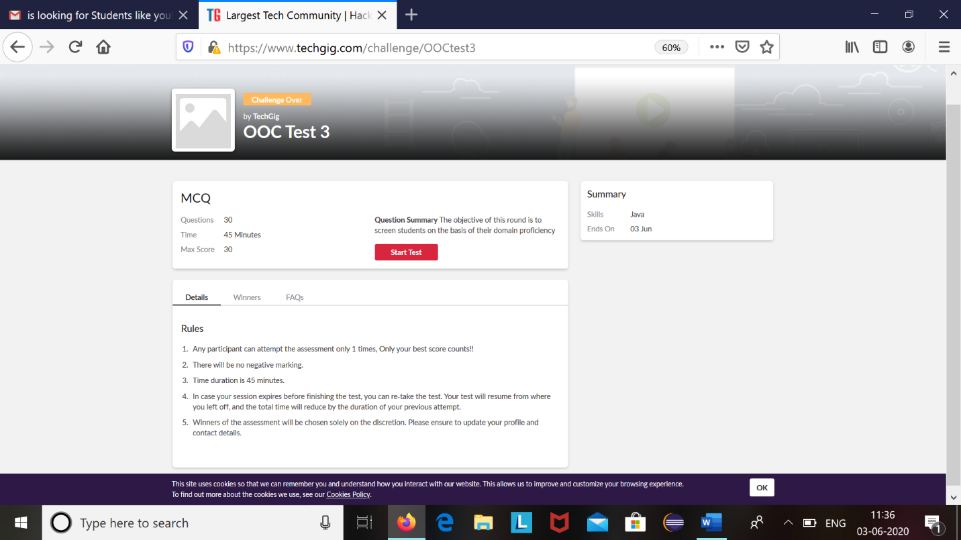

Object oriented concepts internals was conducted today based on the topics of module 2 and module 3 which is of 45 minutes time limit started at 9:15 AM to 9:55 AM. It is of 30 mcq questions based on programming.

The above snapshot is the result sheet which was sent to us by the Techgig team.

Certification Course Details: (Attach the snapshot and briefly write the report for the same)

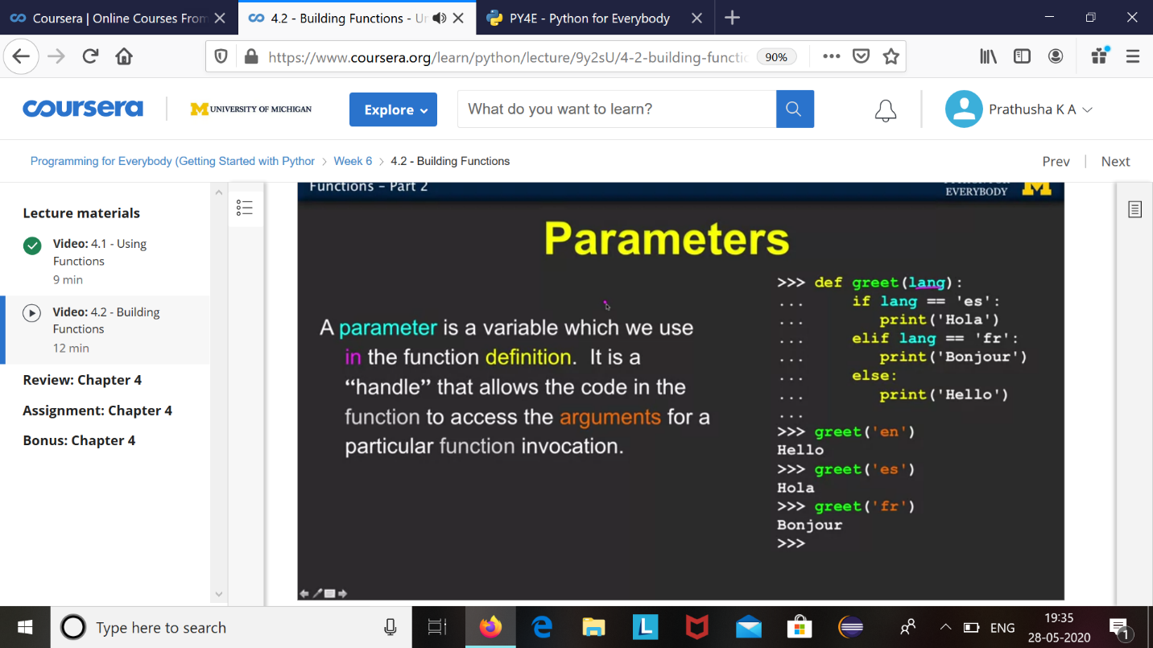

The course I have chosen during the lockdown period is programming for everybody. Since I had previously knew few topics about python iam continuing this course. Since python is gaining a lot of interest in coding platform I have preferred to choose this course.

Coding Challenges Details: (Attach the snapshot and briefly write the report for the same)

The question we had received today was :

Write a Java program to find Last Digit of a^b (a to the power b) for Large Numbers

You are given two integer numbers, the base a (number of digits d, such that 1 <= d <= 1000) and the index b (0 <= b <= 922*10^15). You have to find the last digit of a^b.

Examples:

Input : 3 10

Output : 9

Input : 6 2

Output : 6

Algorithm

Algorithm :

Since number are very large we store them as a string.

Take last digit in base a.

Now calculate b%4. Here b is very large.

-> If b%4==0 that means b is completely divisible by 4, so our exponent now will be exp = 4

because by multiplying number 4 times, we get the last digit according to cycle table in

above diagram.

->If b%4!=0 that means b is not completely divisible by 4, so our exponent now will be

exp=b%4 because by multiplying number exponent times, we get the last digit according to

cycle table in above diagram.

-> Now calculate digit = pow( last_digit_in_base, exp ).

->Last digit of a^b will be ldigit%10

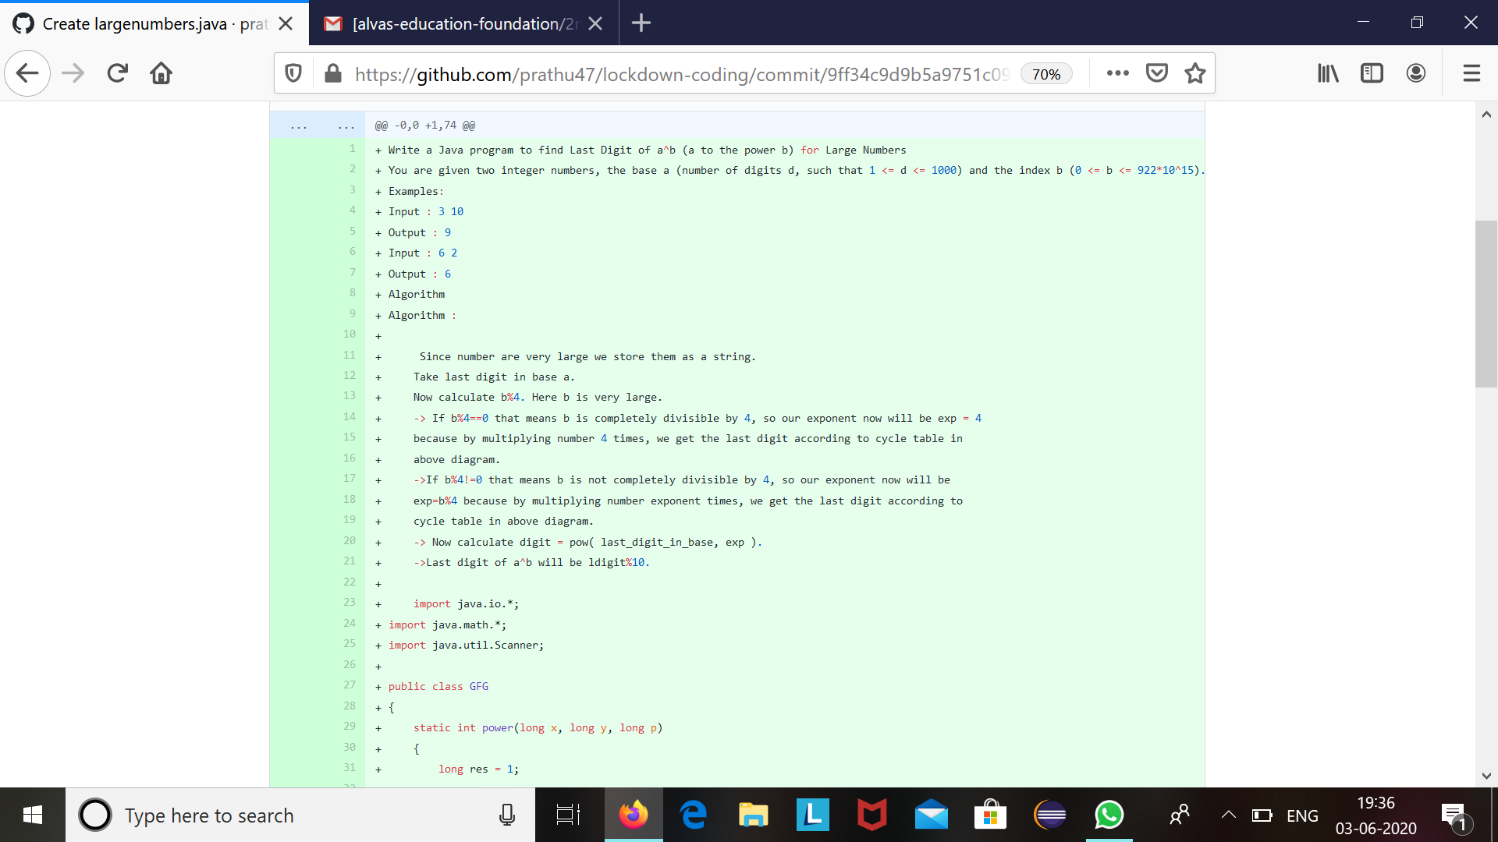

Code:The above snapshot is the code which I have uploaded in my github repository.